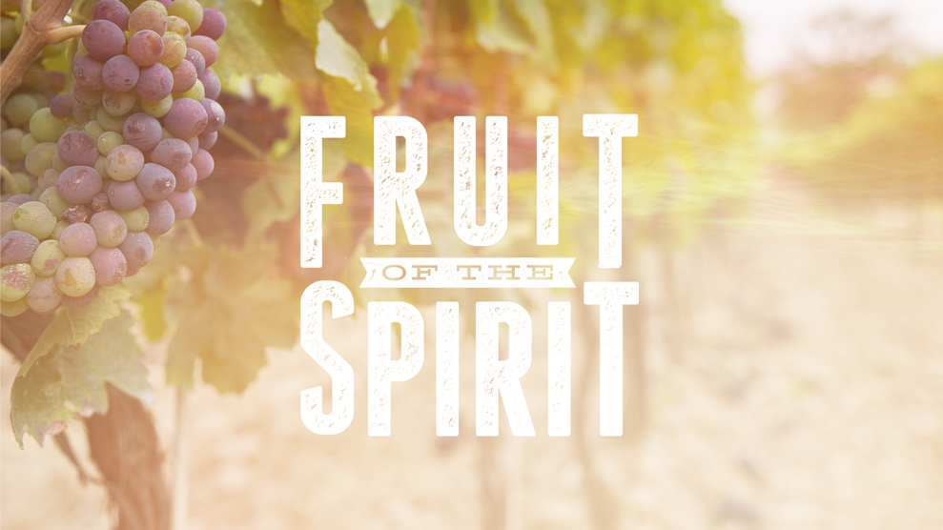

**“Joy”**

*Romans 5:1-11*

Pastor Curtis Sellers

March 22, 2020

**Every relationship needs joy . . . not happiness**

**Happiness:**

Happiness is _____________________________________.

Happiness is based on _____________________________.

Happiness is based on _____________________________.

**Joy:**

Joy is __________________________________________.

Joy is based on __________________________________.

Joy is based on __________________________________.

**Biblical words to express joy:**

1.

2.

3.

4.

“Charis” is the word used for ________________________.

“Chara” is the word for _____________________________.

**The secret of joy is _______________________________.**

1. Joy comes from ________________________________.

2. Joy comes from ________________________________.

3. Joy comes from ________________________________.

4. Joy comes from ________________________________.

5. Joy comes from ________________________________.

**Three joy killers in relationships:**

1. _____________________________.

2. _____________________________.

3. _____________________________.

Fear does three things to a relationship:

A. Fear makes us _________________________________.

B. Fear makes us _________________________________.

C. Fear makes us _________________________________.

**The right perspective means I . . .**

1. Focus on ______________ rather than ______________.

2. Focus on ______________ rather than ______________.

3. Focus on ______________ rather than ______________.

**Why I can be joyful in spite of circumstances . . .**

Because God is __________________________________.

Because God has _________________________________.

Because God will _________________________________.